- Purpose
  - The purpose of this document is to describe the procedure for testing the Corded Swing Machines.
- Scope
  - This SOP applies to all equipment assembly team members. The process applies to the following machine ID’s:
E088066EQM0600BA1000 – Basic Sand Dragon 20, Orbital Sander 20”
E088066EQM0600BE1200 – Crewman 20 ORB, Orbital Strip Machine 20”
E088066EQM0607BA1000 – Basic Sand Dragon 20, Orbital Sander 20” Canadian
E088066EQM0607BA1000 – Crewman 20 ORB, Orbital Strip Machine 20” Canadian
E088068EQM0600BA1000 – Basic Sand Dragon 20, Orbital Sander 20” w/ Weights
E088068EQM0600BE1200 – Crewman 20 ORB, Orbital Strip Machine 20” w/ Weights
E088068EQM0607BA1000 – Basic Sand Dragon 20, Orbital Sander 20” w/ Weights Canadian
E088068EQM0607BA1000 – Crewman 20 ORB, Orbital Strip Machine 20” w/ Weights Canadian
E088068EQM0600ST4040 – Stanley Steemer Orbital Sanding Machine
E088070EQM0600BA1000 – Basic Sand Dragon 28, Orbital Sander 28” w/ Weights
E088070EQM0600BE1200 – Crewman 28 ORB, Orbital Strip Machine 28” w/ Weights
E088070EQM0607BA1000 – Basic Sand Dragon 28, Orbital Sander 28” w/ Weights Canadian
E088070EQM0607BA1000 – Crewman 28 ORB, Orbital Strip Machine 28” w/ Weights Canadian
- Responsibilities
  - The operations manager/supervisor is responsible for enforcing this SOP.
- Materials
  - The proper materials needed for this process are listed on the machine work order.
  - Load Tester / Hi-Pot Tester
- Definitions

- Procedure
  - Lock the machine handle in a suitable operating position.
  - Turn on the hi-pot test unit. Plug the machine into the outlet that goes to the tester.
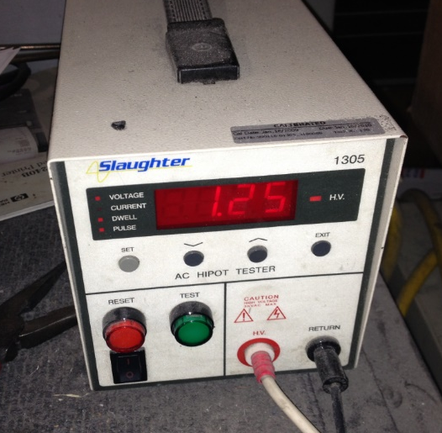
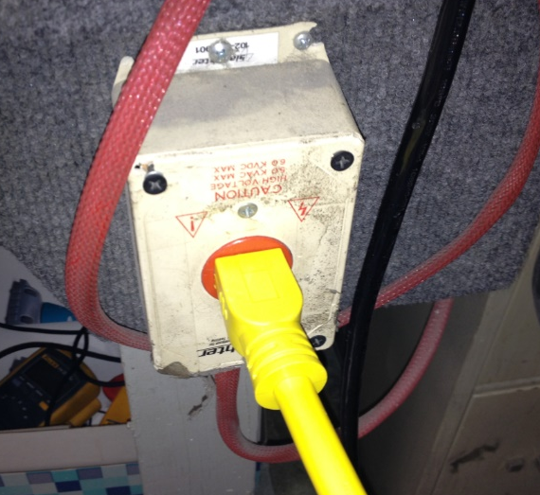

  - Press the green test button on the hi-pot tester. The unit will make a chirping sound. If a buzzer sounds, the machine is wired improperly and should be fixed. As long as the buzzer does not sound, the machine is ok.
  - Plug the machine into an outlet. Hook the electrical meter up to it so that amp draw can be measured. Note: High Speed range must be <20 amps, Low Speed Range must be <10 amps.
  - Operate the machine and make note of the amp draw displayed on the meter. Verify that the machine will also start and operate by using one hand. A new switch may need to be used if this condition is not met.

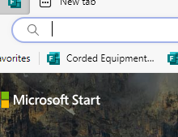
  - Next log into computer and click on Corded Equipment at the top of the page. Record the date, Machine ID, Serial Number, Amperage and pass or fail for Hipot Test. Note: If a failure occurs take a picture and upload into forms.

  - nplug the machine, raise the handle into the transport position, and place a serial number sticker (81180) onto the back of the handle.

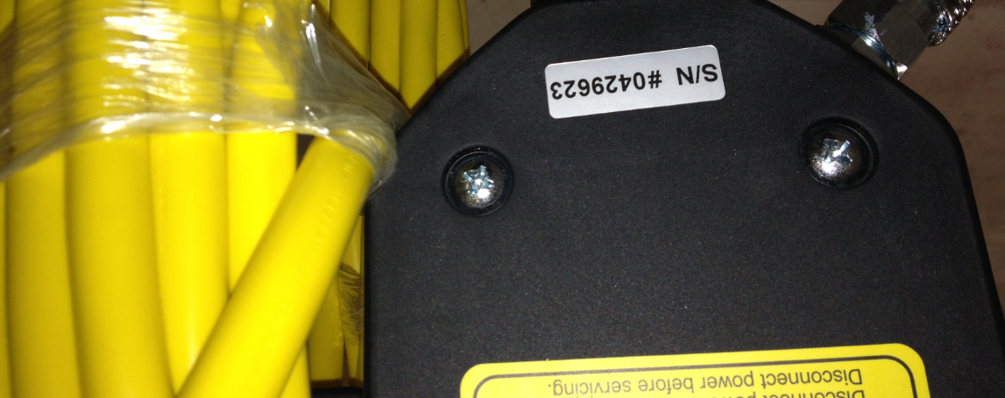

  - Place a manual, a warranty card, pador insert and a tech service card into a plastic bag. Put the bag with the machine. Reference EQ ID for pad or insert.
  - The machine is now ready to be boxed.
- References (optional section as needed)

- Training Guide

Functional Training Groups Requiring Training
Equipment Assembly Group

- SOP Change Control

Date of Change | Reason for Change
4/28/2015 | This is the first version of the S.O.P. hence there are no revisions to this document.
1/16/2018 | Added the Responsibilities Section
2/26/2024 | Changed recording in book to forms and instructions to completed Forms.

Approvals

Submitter/Author Approval:__________________________________ Date:______________________

Management Approval:______________________________________ Date:______________________

QAU Approval:_____________________________________________ Date:______________________

